**In the following booklet we will explore the concept of bioeconomy and different technologies for repurposing waste or by-products primarily from agriculture, but also aquaculture and forestry. Challenges for innovation in the green sector, policy and climate benefits of the technologies are also addressed. The booklet is designed with the purpose of giving teachers a resource to use in the classrooms and teaching, helping to educate new workers in the green sector and speeding up the transition to carbon neutral societies.**

**Research Team and Teacher Reference Group**

*Araldsen, Tord (Norway), Brønnick, Birgitte (Norway), Edström, Mats (Sweden), Fischer, Erik (Sweden/Germany), Fostad, Karen-Marie (Norway), Foth, Sebastian (Germany), Ghalibaf, Maryam (Finland), Gunnarsson, Carina (Sweden), Honkanen, Anne (Finland), Laaksonen, Ilmari (Finland), Laurell, Carina (Sweden), Ievins, Indulis (Latvia), Lundervold, Amalie (Norway), Sollihagen, Selma (Norway), Stuparu, Adelina (Sweden), Vircava, Ilze (Latvia)*

Innhold

**Background** 5

**Learning Goals** 6

**Part I: The Basics of Bioeconomy** 7

Terminology 7

Bioeconomy 8

Linear versus Circular Economy 9

Linear economy 9

Circular economy 9

Difference between linear and circular economy 9

Linear bioeconomy 9

Circular bioeconomy 10

Cascade effects 11

The bioeconomy value pyramid 11

**Part II: Technologies and Challenges** 13

Circular Agriculture - a step up 13

Circular Forestry 14

Biorefining 15

Technologies used to achieve circular bioeconomy 16

Dewatering of manure 16

Pretreatment of cellulose rich material 18

Biogas Production - Anaerobic digestion 20

Upgrading Organic Fertiliser 26

Pyrolysis 29

Gasification 31

Protein Extraction 33

Phosphorus recovery 35

Nitrogen recovery 37

**Part II: Implementation and Solutions** 39

Key Challenges to Innovation and Creation 39

Technological development 39

Market and financial uncertainty 39

Sustainability and environmental impact 39

Political and regulatory framework conditions 40

Global and European Policy 40

The impact of bioeconomy on society and environment 41

The climate benefit of using biogas and bio-fertiliser 42

Positive Impact with Increased Production: 43

Further possibilities within bioeconomy 43

Reference list 46

Thank you 47

# **Background**

The project BREC connects agricultural schools, authorities and researchers to spread circular agricultural practices among practitioners and pilot technologies driving circular bioeconomy.

The Interreg-project “Bridging the Gap between Research and Education in the Circular Bioeconomy” (BREC) was dedicated to tackling some of the challenges associated with the transition from a linear to a circular economy. In the agricultural sector, there has been a vast technological development creating the issue of “analysis paralysis”. This phenomenon occurs when numerous new technologies are introduced at the same time, creating a dilemma for effective decision-making. BREC identified several key technologies - such as biogas production, protein extraction, phosphorus extraction, nitrogen enrichment, biochar production, and their accompanying pre- and post-treatment processes - that are central to shift towards a circular economy.

The objective of the work was to create a knowledge bank with good examples/practice examples of how the different technologies can effectively address specific agricultural challenges. This bank can serve as a comprehensive toolkit, benefiting agricultural schools in educating the next generation of farmers and catering to seasoned practitioners, advisers and farmers associations.

Our belief is that by disseminating knowledge and sharing firsthand experience concerning new technologies, societies can mitigate the challenges of analysis paralysis. Empowering the new generation of farmers with exposure to the technologies is a central objective of this initiative. Our aspiration is that agricultural schools across Europe can showcase what circular bioeconomy means in practice.

# **Learning Goals**

The BREC Learning Goals were developed by the teacher reference group in spring 2023 to outline what students should achieve through the program. The learning framework is symbolised by a tree, representing the growth of knowledge the students will obtain.

* The roots of the tree signify the foundational knowledge students are expected to acquire.
* The trunk represents the core concepts students need to fully understand.
* The crown illustrates the skills and abilities students should develop, showcasing what they should be able to do after completing a bioeconomy lesson.

The learning goals and lesson plans are flexible and can be adapted to meet individual needs. The comprehensive lesson plan package can be implemented as a whole or tailored to fit into various courses and curricula.

# **Part I: The Basics of Bioeconomy**

## Terminology

## Bioeconomy

[Bioeconomy](https://www.youtube.com/watch?v=hx-jZmE-2_U) is an economy where materials, chemicals and energy originate from renewable bio-based raw materials.

To engage students in further exploring the definition of the bioeconomy, an interactive exercise can be used. On a whiteboard write the term ‘bioeconomy’ in the middle. Invite the students to think of different concepts, processes, activities that the term can involve. Write down the answers surrounding the term and create a “word cloud”. To take the exercise a step further, you can use the word cloud as a bingo exercise.

The link provides a video explanation for students and can be used as an introduction to the topic in classrooms. While the video is playing you can cross the words that the students came up with in the word cloud. Did you cross at least six words off in the cloud?

Another exercise can be a reflection. Is the bioeconomy what I had expected? Was there anything surprising in what we have discovered so far? If yes, what was it? If not, clearly the class needs to go more in depth and explore further knowledge connected to the bioeconomy.

A linear bioeconomy refers to the production of organic materials, such as plants or animals, for food, feed, or other products without considering the natural capacity to regenerate these materials. Additionally, byproducts from the production process, as well as other organic resources like animal manure, are often not reused or utilised efficiently. This inefficiency can result in the loss of valuable nutrients and organic material, potentially leading to environmental issues such as pollution and eutrophication

## Linear versus Circular Economy

### Linear economy

In a linear economy, production and consumption follow a straightforward model where goods are produced, used, and then discarded as waste (Miljødirektoratet, 2022). There are limited efforts to reuse, recycle, or repurpose waste. Resources are extracted, consumed, and ultimately end up in landfills or are incinerated. This model primarily focuses on economic growth and production without adequately considering the environmental and social consequences.

### Circular economy

In a circular economy, resources are viewed as part of a continuous flow where materials and products are used, recovered, and recycled to create a closed loop (Miljødirektoratet, 2022). The goal is to minimise waste and resource loss through practices such as reuse, repair, and recycling. This model emphasises preserving the value of products and materials for as long as possible by designing them with durability, reparability and recyclability in mind. It also promotes sharing and using services rather than owning products individually, reducing the total volume of goods required. The circular economy promotes a sustainable and resource-efficient system while considering environmental and social impacts

### Difference between linear and circular economy

The fundamental difference between linear and circular economies lies in their approaches to resource use and waste management. In a linear economy, resources flow in a straight line from production to disposal, often resulting in waste. In contrast, a circular economy aims to create a closed-loop system where materials and products are continuously recovered, reused, and recycled, minimising waste and maximising resource efficiency (Miljødirektoratet, 2022).A diagram of circular economy

### Linear bioeconomy

In a linear bioeconomy, production and consumption follow a linear model where organic material is used as a raw material to produce goods, energy, or chemicals. After its use, the organic material is discarded as waste without being recycled or reused. Instead of recovering and reusing existing organic material, new organic material

is continuously extracted, often without considering natural regrowth. The focus in a linear bioeconomy is primarily on economic growth and the benefits of utilising organic material, without necessarily addressing the environmental and social consequences

An example of a linear bioeconomy is beef production in Brazil, where cattle ranching drives deforestation in the search for greener pastures (Reis, T., Zu Ermgassen, E., & Pereira, O. 2023). Another example is overfishing. It is estimated that about 34% of fish stocks are overfished, leading to a decline in fish stocks (Ritchie and Roser 2021). A third example is sea-based fish farming, where almost all the fish slurry (combination of fish excreta and feed left-overs) is being let out directly to the surrounding water and ecosystem (Spilling, 2016).

### Circular bioeconomy

In contrast to a linear bioeconomy, a circular bioeconomy will consider biological resources as a continuous flow. Organic material, byproducts and nutrients are gathered, used, recovered and recycled in a manner to create an infinite loop. The aim is to satisfy the societies need for materials and energy without overexploiting the capacity of our planet. Photosynthesis plays a big role in the circular bioeconomy, as it is the engine that keeps carbon running in its cycle.

Optimising the management of resources in a way that complies with the principles of a circular bioeconomy can be quite difficult, as we need in-depth knowledge about the limits of nature and because existing knowledge is often based on lessons learned from the linear economy. Within a circular bioeconomy, biological waste such as wastewater, food waste and wood can be recycled. Solutions include, for example, restoring nutrients through composting or nutrients *and* energy through biogas plants.

Circular bioeconomy practices, such as using waste-derived organic fertilisers and soil improvers, present both opportunities and challenges. While these practices aim to close resource loops and reduce waste, they also come with inherent risks that must be carefully managed. One of the primary concerns is the potential spread of contaminants.

These can include:

* Microplastics: Waste streams often contain plastic particles that can persist in the environment.
* Chemical pollutants: Industrial and household waste may introduce harmful chemicals into the fertiliser.
* Pathogens: Organic waste can harbour disease-causing organisms that pose risks to human and plant health.
* Heavy metals: Certain waste sources may contain elevated levels of metals that can accumulate in soil over time.

To mitigate these risks, regulatory frameworks have been established in many regions. These typically include:

* Strict limit values for contaminants
* Mandatory treatment processes to reduce pathogen loads
* User restrictions based on crop type and land use
* Regular testing and quality assurance protocols

While these measures aim to ensure the safe use of waste-derived products, scepticism persists among some stakeholders. Critics argue that:

* Long-term effects of repeated application are not fully understood
* Certain contaminants, like emerging pollutants or nanomaterials, may not be adequately addressed by current regulations
* Enforcement and monitoring can be challenging, especially in regions with limited resources

Despite these challenges, proponents of circular bioeconomy practices argue that the benefits often outweigh the risks when proper precautions are taken. They point at successful implementation in various countries and the potential for these practices to reduce reliance on synthetic fertilisers, minimise waste, and improve soil health.

Ongoing research and technological advancements are focused on improving detection methods, developing more effective treatment processes, and enhancing our understanding of the long-term impacts of these practices on soil ecosystems and food safety.

Ultimately, the successful and safe implementation of waste-derived biofertilizers and soil enhancers requires a balanced approach that combines rigorous scientific assessment, adaptive regulation, and continuous stakeholder engagement to address concerns and optimise benefits.

### Cascade effects

Cascade effects play an important role within the bioeconomy and are a key principle for achieving sustainable utilisation of biological resources. This principle is about utilising organic material residues and waste fractions in a hierarchical manner where the most valuable components are taken out first, and the residues are used for other purposes of lower value. See for example the waste pyramid model for the bioeconomy.

### The bioeconomy value pyramid

The “bioeconomy value pyramid” represents a hierarchical structure for resource utilisation within the bioeconomy (Stegmann, Londo, & Junginger, 2020). The model shows how the biomaterial goes through several stages of use to extract high-value products before moving on to low-value applications. At the top of the pyramid, we find the production of biochemicals and medicines which have a low volume but high economic value. These valuable products are of great importance to both the health industry and other high-tech applications. The residues from this process can then go on to production of food and feed. Finally, when the resources can no longer be extracted, they can be used for energy production, which is a production that requires a high volume of biomass. The waste pyramid ensures that the organic material is optimally utilised, and that valuable resources are extracted before they are used for less valuable purposes, which may contribute to a more efficient and circular bioeconomy.

*Figure SEQ Figure \* ARABIC 2. The bioeconomy value pyramid the different types of products from biological resources and how they are assorted in terms of value and volume.*

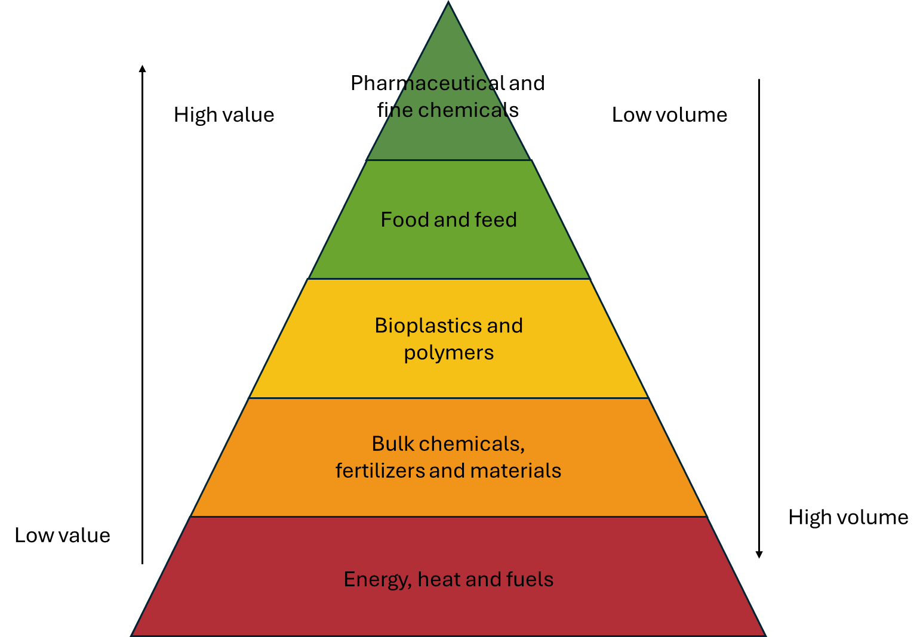

# 

# **Part II: Technologies and Challenges**

## Circular Agriculture - a step up

Circular agriculture involves reusing and optimising resources to minimise waste. Instead of a linear “take-make-dispose” model, circular agriculture promotes resource efficiency, resilience, and sustainability.

Key Principles:

* **Sustainability:** Sustainability is the balance between the environment, equity, and economy. Sustainable development is development that meets the needs of the present without compromising the ability of future generations to meet their own needs.
* **Resource Efficiency:** Aims to use everything for something, ideally as high up in the bioeconomy value pyramid as possible.
* **Biodiversity:** Diverse cropping systems enhance resilience and support ecosystems.

Examples of new uses for agricultural crops and waste:

* **Biogas:** Decomposing the organic material in an airtight container gives a high energy gas that can be used for heat, electricity, or fuel.
* **Organic fertiliser:** After anaerobic digestion during biogas production, the remaining organic residue (digestate) is a nutrient-rich substance that enhances soil fertility and promotes plant growth. It contains valuable nutrients like nitrogen, phosphorus, and potassium.
* **Biochar**: Produced from organic material through pyrolysis (decomposition at high temperature without oxygen), biochar improves soil properties and stores carbon.
* **Plant Proteins:** Extracting proteins from plants like grass or silage provides alternatives to imported animal-feed proteins, such as soy.
* **Recycled nutrients:** Reusing phosphorus, a limited resource essential for food production, is imperative.
* **Feedstuff:** Insects like black soldier fly larvae or mealworms, reared on agricultural byproducts (e.g., fruit, vegetable, and grain scraps), are processed into insect meal. This high-protein animal feed is suitable for poultry, pigs, and fish in aquaculture.

**Indirect Land Use Change (ILUC):** ILUC refers to the unintended environmental consequences of converting land for agricultural use due to changes in land use elsewhere. For instance, when existing cropland is diverted to biofuel or other production, additional land (such as forests or grasslands) may be cleared to compensate for displaced food or feed production. This can lead to deforestation, loss of biodiversity, and increased carbon emissions, undermining the environmental benefits of biofuels or bioenergy.

In contrast, using ILUC-free organic material, such as crop residues, manure, and organic waste, offers significant environmental advantages. Sourced from existing agricultural operations without requiring additional land or deforestation, ILUC-free organic material is more sustainable. This approach allows farmers to generate renewable energy (biogas) and bio-fertilizers while minimising greenhouse gas emissions, reducing reliance on synthetic fertilisers, and avoiding negative impacts on food production and ecosystems.

*An illustration of an agricultural circular bioeconomy system*

## Circular Forestry

Forests are complex, living ecosystems that also serve as significant reservoirs of organic material—the organic matter that constitutes trees, plants, and other forest elements. These ecosystems are not static; they undergo continuous change, shaped by a combination of human management practices and environmental conditions.

Historical Focus: Circular Management

* Traditionally, forest management has focused on circular practices—replanting after harvesting to ensure a sustainable cycle of growth and regeneration
* Circular management aims to maintain forest health, biodiversity, and ecosystem services.
* The New Frontier: This concept implies that forestry is entering a new phase characterised by the application of advanced technologies, data-driven approaches, and improved management techniques. These innovations aim to optimise various aspects of forest management, including:
  + Maximising timber yield while maintaining ecosystem health.
  + Balancing economic, environmental, and social goals.
  + Minimising waste by enhancing the utilisation of biomass for energy and other products.
  + Leveraging technologies such as drones, satellite imagery, AI, and data analytics to improve monitoring, harvesting, and regeneration processes

Beyond Replanting:

Optimization is the key. It involves making the best decisions to achieve specific objectives while efficiently using available resources.  Just like agriculture, forestry serves various purposes:

* Woodworking Industry: This sector focuses on processing sawn wood, producing bioenergy, and using wood in construction.
* Furniture Industry: Wood is transformed into beautiful and functional furniture pieces.
* Paper and Pulp Industry: Forests provide the raw material for paper and pulp production.
* Cellulose-Based Fibres and Plastics: Innovative materials emerge from forest resources, such as bioplastics and vanillin.

## Biorefining

General Principles of a Biorefinery

In an agricultural setting, biorefining involves converting various forms of organic material into valuable products such as biofuels, chemicals, and materials. The general principles of biorefining in an agriculture setting are:

* **Resource Efficiency**: Maximise the use of agricultural residues and by-products (e.g., straw, husks) to reduce waste and increase the value of what is otherwise considered a waste product.
* **Sustainable Practices**: Implement processes that are environmentally friendly and support sustainable agriculture by minimising energy consumption, reducing emissions, and conserving resources.
* **Value Addition:** Transform raw organic material into higher-value products like biofuels, bioplastics, and specialty chemicals, or protein which can provide economic benefits and support the agricultural economy.
* **Integrated Processing:** Use integrated systems to process different types of organic material together, optimising overall efficiency and reducing costs. This can involve multiple stages, such as pretreatment, conversion, and refining.
* **Circular Economy:** Promote the recycling of by-products and waste back into the production cycle, ensuring that resources are used efficiently and reducing the environmental footprint.
* **Innovation and Technology:** Employ advanced technologies and processes, such as enzymatic hydrolysis or fermentation, to improve the efficiency and effectiveness of organic material conversion.
* **Economic Viability:** Ensure that biorefining processes are economically feasible by balancing the costs of technology, energy, and raw materials with the market value of the end products.
* **Local Integration:** Adapt biorefinery systems to local agricultural practices and available Organic material types to enhance the relevance and impact of biorefining in specific regions.

These principles guide the development and operation of biorefineries in agricultural settings, aiming to optimise the use of organic material while supporting sustainable and economically viable practices.

## Technologies used to achieve circular bioeconomy

Implementing a circular economy requires innovative process design, which is largely driven using advanced technologies. These technologies play a vital role in converting materials, such as agricultural -by-product and organic waste, into valuable resources by modifying their properties and enhancing their potential for reuse.

### Dewatering of manure

Separation of manure into liquid and solid fractions is commonly practised for several reasons. This process plays a crucial role in improving manure management and enhancing environmental sustainability, particularly in large-scale agricultural operations. Each technology has different advantages, depending on the moisture content of the manure, the scale of the farm, and the intended use of the separated materials such as energy production, fertiliser, or environmental management. The key benefits include:

* **Improved Nutrient Management:** The liquid fraction typically contains a higher concentration of nitrogen, which is more readily available for plant uptake. This can be applied as a liquid fertiliser for crops to optimise nutrient uptake. The solid fraction contains more organic matter, phosphorus, and potassium, making it suitable for slow-release fertilisers or soil conditioners.
* **Easier Handling and Storage:** Liquid manure is easier to pump and spread using irrigation or tankers, making application more efficient. The solid fraction, being more compact, is easier to store, transport, and process into compost or for drying.
* **Reduction of Odour and Emissions**: Separating manure helps reduce odours and greenhouse gas emissions, especially methane and ammonia, as the liquid fraction can be more easily treated or spread to minimise environmental impacts.
* **Biogas Production Efficiency:** In biogas plants, separating manure can enhance digestion efficiency. The solid fraction, rich in organic material, is ideal for anaerobic digestion, while the liquid fraction can be recycled or treated separately.
* **Improved Water Quality**. By separating the fractions, it's easier to manage nutrients and prevent nutrient runoff into water bodies, helping protect water quality in surrounding areas.

***Technologies used for solid liquid separation.***

*Several technologies are used to separate manure into liquid and solid fractions, depending on the scale of operation, efficiency needs, and specific goals. The most common ones are marked with a star. (*)*

* ***Mechanical Separation:***
  + ***Screw Press Separators\*****: These use a screw mechanism to press the solid fraction out of the manure while allowing the liquid fraction to pass through. It's one of the most common methods used on farms, especially for dairy and pig manure.* 
    - *The advantages are that it is simple and effective for a wide range of manure types and has low energy requirements and relatively low maintenance. Suitable for medium to large scale farms.*
  + ***Rotary Drum Separators\*****: A rotating drum with mesh allows liquids to filter through while the solids are retained and dewatered.*
    - *The advantage is that it is good for high-volume manure processing, and it may operate continuously with need of minimal maintenance. The application is usually large-scale dairy farms and biogas facilities.*
  + ***Belt Press Separators****: A continuous belt squeezes the manure between rollers, separating solids from liquids by pressure. Belt press separators are effective at recovering a high percentage of solids, making them common on farms that compost manure or need solid material for other uses.*
    - *The advantage is the hid solid content in the separate material, and it is suitable for manure with high fibre content. The application is for dairy farms and poultry farms where the solid fraction is valuable for bedding, compost or for further drying into organic fertiliser pellets.*
  + ***Vibrating Screens****: These screens shake the manure, allowing liquids to pass through while solids are retained. It is often combined with other systems for more efficient separation.*
* ***Centrifugation:***
  + ***Centrifugal Separators*:*** *These use high-speed spinning to separate solids from liquids based on their densities. The heavier solid particles move to the outer edges, and the liquid remains in the centre.* 
    - *The advantage is that it is very efficient for fine particle separation and can handle large volumes. Typical application is when it is needed for advanced separation for better nutrient management like biogas plants and recovery of nutrients such as phosphorus.*
* ***Decanting and Settling Ponds***
  + ***Gravity Settling Tanks or Ponds****: Manure is allowed to settle in large ponds or tanks where the heavier solid fraction sinks to the bottom, and the liquid can be syphoned off from the top. This is a low-tech but effective method, often used in large-scale or less mechanised farms.*
    - *The advantage is the minimal equipment and operational cost as it is easy to manage. Often used in pig and cattle farms when land is available for large storage ponds. The need for cover may reduce the cost effectiveness.*
* ***Filtration Systems:***
  + ***Geotextile Bag Filters:*** *These are large permeable fabric bags into which manure is pumped. The liquid fraction seeps through the fabric while the solids are retained inside. It is an emerging technology in the agriculture sector.*
    - *Advantage is that it is portable and easy to install technology and has low maintenance. Suitable for small and medium farms for simple manure management.*

*The report “Climate-friendly agricultural practice in Latvia Separation of liquid manure and digestate” from Latvia University of Life Sciences and Technologies (2020) gives practical examples and applications in an agricultural setting.*

### Pretreatment of cellulose rich material

Many agricultural by-products, such as straw and corn stover, are rich in cellulose, hemicellulose, and lignin. Cellulose, a key component of plant material, is tough and resistant to degradation, making these materials difficult to digest for livestock, particularly monogastric animals (e.g., pigs and poultry) and, to a lesser extent, ruminants (e.g., cattle and sheep), however pretreatment softens the tough, fibrous structure of cellulose-rich feedstuffs, making them easier for animals to chew and digest. This improves the palatability of the feed, encouraging better intake by livestock. Pretreatment helps break down these structures, making it easier for microorganisms to access and digest the material. Agricultural waste rich in cellulose, such as crop residues, is often abundant but underutilised. Pre-treating these materials enables more efficient recovery of energy and nutrients, turning waste into valuable inputs for processes like bioenergy production

**Enhanced Biogas Production and better bio-fertiliser:**

* **Anaerobic Digestion Efficiency:** In biogas plants, cellulose-rich materials (e.g., straw, corn stover) are often used as substrates. Pretreatment breaks down the cellulose and hemicellulose into simpler sugars, which microorganisms can ferment into biogas.
  + **Higher Yields:** By improving the digestibility of the material, pretreatment increases the overall yield of biogas, making the process more efficient and cost-effective.
  + **Quicker Processing:** Pre-treating cellulose-rich materials reduces the time needed for the material to break down in bioreactors or composting systems. This shorter retention time allows for faster turnover and greater processing capacity.
  + **Uniform Substrate:** Pretreatment can reduce large, fibrous plant materials into smaller, more uniform particles, improving the mixing of substrates in biogas plants.
  + **Lignin Breakdown:** Lignin, a complex organic polymer in plant cell walls, can inhibit microbial activity in anaerobic digestion. Some pretreatment methods help to reduce the lignin content, minimising its inhibitory effects and allowing for better microbial digestion.
  + **Nutrient Release:** Pretreatment helps release nutrients like nitrogen, phosphorus, and potassium locked in plant cell walls, making them more readily available when used as fertilisers or soil conditioners after composting or digestion.

**Enhance Nutrient Availability for feed:**

* **Release of Energy:** Pretreatment helps unlock the energy stored in the complex carbohydrates (cellulose and hemicellulose). Once broken down, these can provide a more accessible energy source for animals, leading to better growth rates and feed efficiency.
* **Increased Protein Availability:** While cellulose itself does not contain protein, pretreatment often helps release bound nutrients, including proteins and amino acids from plant cell walls, making them more bioavailable.
* **Lignin and Tannins:** Lignin, found in plant cell walls, is not digestible and can bind nutrients, making them unavailable to animals. Certain pretreatment methods help to reduce lignin content, increasing the overall nutritional quality of the feed.
* **Toxin Removal:** Some agricultural residues contain compounds like tannins or other anti-nutritional factors that interfere with digestion. Pretreatment can help remove or neutralise these substances.
* **Softening the Material**: Pretreatment softens the tough, fibrous structure of cellulose-rich feedstuffs, making them easier for animals to chew and digest. This improves the palatability of the feed, encouraging better intake by livestock.
* **Enzyme Hydrolysis:** Certain chemical or enzymatic pretreatment processes can break down complex carbohydrates into simpler sugars, improving the carbohydrate profile in the feed. This can help balance the energy content when combined with protein sources, making for a more complete diet.
* **Utilising Agricultural By-Products:** Pretreatment allows low-cost, cellulose-rich agricultural by-products, which would otherwise be wasted, to be turned into valuable livestock feed. This provides farmers with an affordable and sustainable alternative to conventional feed sources.
* **Better Utilisation of Nutrients**: Pretreatment leads to improved nutrient absorption and digestion, resulting in less waste excreted by animals. This is especially important in intensive farming operations, where maximising feed efficiency is key.

**Common Pretreatment Methods:**

* **Mechanical Pretreatment:** Shredding, grinding, or chopping organic material into smaller particles to increase surface area.
  + **Common uses:** Improves palatability and digestibility for animal feed; enhances biogas production by making the organic material easier for microbes to break down.
* **Chemical Pretreatment:** Using acids (e.g. Dilute Sulfuric Acid), alkalis (e.g., Sodium Hydroxide, Ammonia), or enzymes to break down cellulose, hemicellulose, and lignin.
  + **Common uses**: Alkali enhances digestibility in ruminant feed; improves efficiency in bioenergy production by opening the cellulose structure. Acids release fermentable sugars from biomass for bioenergy production (e.g., ethanol and biogas)
* **Thermal Pretreatment:** Applying heat or steam to soften the organic material and break down its structure.
  + **Common uses:** Widely used in biogas and bioethanol production; also, can be applied to improve animal feed digestibility especially for fibrous materials.
* **Biological and Enzymatic Pretreatment:** Using specific fungi to degrade lignin and make cellulose more accessible or using specific enzymes (like cellulases and hemicelluloses)
  + Not very common methods and is costly for large-scale applications.

Pretreatment methods are essential in making cellulose-rich agricultural residues more accessible for microbial digestion, whether in animal feed or bioenergy production. Each method has specific advantages depending on the type of organic material and the intended use, whether it’s for improving feed digestibility or for converting biomass into renewable energy sources like biogas or biofuels

Read more in the review article by Rasaq et al. (2024) “Green and sustainable pretreatment methods for cellulose extraction from lignocellulosic biomass and its applications”

### Biogas Production - Anaerobic digestion

Biogas is produced through a natural process called anaerobic digestion, in which organic materials—such as organic waste, plant residues, and livestock manure—are broken down by microorganisms in an oxygen-free environment. This process produces a mixture of gases, primarily methane (CH₄) and carbon dioxide (CO₂), making biogas a renewable energy source. One of the main advantages of anaerobic digestion is that it reduces the mass and odour of organic waste, stabilising it and converting it into valuable products like biogas and bio-fertiliser.

*Sources for bio waste that can be anaerobically digested to produce biogas and biofertilizer.*

Biogas Composition:

Methane (CH₄):

* Methane is the biogas primary energy component.
* Methane content typically ranges from 45% to 75% by volume.
* The energy content of biogas varies due to this variation of methane concentration.

Carbon Dioxide (CO₂):

* CO₂, the other major component in biogas.
* It’s a product of the anaerobic digestion process and can be captured as bio-CO2 which can replace fossil CO2 used to enhance plant growth in greenhouses

The size of a biogas plant is important, as how the biogas is utilised depends on the amount of energy produced. A large biogas plant can often justify the investment in a gas upgrading system. In contrast, small to medium-sized plants typically produce biogas for electricity generation and heating

*Biogas plant may have the potential to produce upgraded biogas as fuel to vehicles*

Biogas Production Pathways - digesting of complex organic material

The biogas production process consists of several microbiological metabolic steps, driven by various species of bacteria within a reactor. Organic material is broken down anaerobically, meaning without the presence of oxygen. While some bacteria in the reactor can tolerate oxygen, others cannot. The final step, methanogenesis, is performed by strictly anaerobic bacteria that cannot survive in oxygen and are highly sensitive to temperature fluctuations and low ph. To optimise biogas production, the environment for these microorganisms must be closely monitored, including measures of temperature, alkalinity and volatile acids.

In the biogas process, large organic molecules are broken down into the gases methane and carbon dioxide. This is possible due to a very complex interaction between different types of microorganisms. For example, one organism can produce the “food” for another organism or create the right condition for another organism to thrive by changing the pH of the environment. Everything that is not broken down into gas is residues and can be used as organic fertiliser or a soil amendment product. This includes nutrients, such as nitrogen, phosphorus and potassium, in the form of plant available nutrients. The organic fertiliser also includes the carbon that was not possible to convert to gas, which can often be estimated to 50% of the carbon in the original organic material, but this may vary with the material.

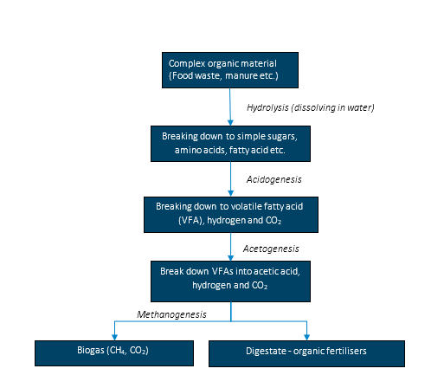

*Simplified description of the biogas process with the different biochemical and microbiological steps.*

Bioreactors: 

A bioreactor is a sealed, airtight container or tank equipped with a stirring mechanism to ensure uniform mixing. In continuous-flow systems, the substrate is pumped in at the same rate as the digested material (bio-fertiliser) is removed. The average retention time inside the bioreactor typically ranges from 20 to 40 days, depending on the process conditions. Naturally occurring microorganisms break down the organic material, producing biogas. Biogas is collected from the headspace of the bioreactor.

med middels konfidens

A biogas boiler burns biogas to produce heat, which can be used to warm buildings. A combined heat and power (CHP) engine or turbine generate both heat and electricity. About one-third of the energy is converted into electricity, while the remaining two-thirds can be used for heating.

Upgrading to Biomethane:

Biomethane, also known as renewable natural gas, is purified biogas that has been upgraded by removing CO₂ and other impurities like hydrogen sulphide.  Biomethane is compatible with existing natural gas. The upgrading process can be achieved using various techniques, such as scrubbing, membranes, chemical treatments, or temperature-based methods. With a higher energy content than biogas, biomethane is a cleaner alternative to fossil fuels, particularly for the transportation sector. The upgraded biogas can also be further processed into compressed or liquefied forms for easier storage and handling. 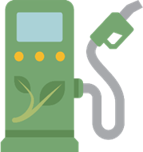

Bio-CO2: A Green Solution for Industrial Needs

During the production of biogas, a significant byproduct emerges which is bio-CO2. This carbon dioxide, which is derived from biological sources, can play a pivotal role in reducing industrial emissions. There are two primary approaches to utilising this bio-CO2:

* **Direct use:** Involves employing the bio in its gaseous form. For example, to produce biochemicals, fuel and concrete, among other things.
* **Liquefaction:** Converted into a liquid form. This method, while more energy-intensive, offers several advantages. Liquid CO2  is denser and can be stored and transported more efficiently than its gaseous counterpart. This is particularly beneficial for applications that require large volumes of CO2 or where storage space is a constraint.

However, the energy costs associated with liquefaction must be weighed against these benefits. If the bio-CO2 is upgraded to methane through processes like methanation, it can replace industrial CO2 in smaller quantities, potentially leading to significant reductions in emissions.

Increasing biogas yield using methanisation

Methanation is a process that converts carbon monoxide (CO) and carbon dioxide (CO₂) into methane (CH₄) using hydrogen (H₂), which is essential for producing methane from non-methane sources and improving the efficiency and purity of biogas. For example, excess electricity from wind farms can be used to produce hydrogen through electrolysis, and this hydrogen can then be used in methanation or added to an anaerobic digester to enhance methane production.

Conclusion**:**

Anaerobic digestion is a common waste treatment process for biological waste, such as wastewater sludge and food waste. This process reduces the volume of waste, stabilises it biologically, reduces pathogens, and minimises odour potential before storage and use as bio-fertiliser. Controlled anaerobic digestion of manure also increases nutrient availability, particularly nitrogen, and makes it easier to spread.  Biogas offers a vital solution by meeting energy demands while protecting the environment. By converting organic waste into energy and stable carbon, we turn discarded materials into a valuable, sustainable resource for the future.

Advantages of Biogas Production:

* Efficient Waste Management: Biogas offers an efficient way to handle organic waste, including food waste and animal waste. It allows for the recycling of important nutrients like nitrogen, phosphorus, and potassium, which can be used as fertiliser in agriculture.
* Job Creation: The biogas industry, through its value chain from waste collection to biogas production, can generate a significant number of jobs and economic value.
* Renewable Resource: Biogas and biofertilizer are made from resources that are renewable, reducing our dependence on non-sustainable resources like oil and chemical fertilisers.

Disadvantages of Biogas Production:

* Dependence on the Organic Material: Steady production of biogas requires enough organic material. Competition for these materials from other sectors can lead to resource allocation challenges.
* Odour and Location Issues: Waste management can generate unpleasant odours, making the location of biogas plants critical to minimise potential odour problems near populated areas.
* Temperature Influence: Biogas production is temperature-dependent, and climatic conditions can affect production efficiency. In colder areas, more resources are needed to insulate and heat the facilities, increasing production costs.
* Costs and Investments: Establishing a biogas plant involves significant costs and investments, particularly for infrastructure and bio-fertiliser storage.
* Methane Leakage: Methane emissions may occur during the storage of bio-fertilizer if the tank is not properly sealed. Additionally, methane can escape from the biogas plant if it is not effectively burned or captured.

While there are challenges, many can be managed through planning, technology development, and efficient operations. Biogas production has systemic challenges that require political will to address. Despite the disadvantages, the knowledge and technology to produce biogas exist, making it a viable option for sustainable energy production.

*Large biogas plant*

An example in Norway is Den Magiske Fabrikken (The Magic Factory), which has the capacity to produce approximately 120 GWh of biogas. At the facility, food waste and livestock manure are transformed into biogas, organic fertiliser from the dietate, and vermicompost and green CO2. The food waste comes from approximately 1.2 million residents in Eastern Norway, while the livestock manure is sourced from cattle and pig farms in Vestfold.

However, The Magic Factory is more than just a biogas plant. It serves as a hub for connecting industries through various projects and initiatives, laying the groundwork for sustainable development, innovation, and green growth. The regional waste management company, VESAR, has established a Knowledge and Experience Centre adjacent to the biogas facility. This centre provides children and young people with hands-on learning opportunities about waste sorting, recycling, food production, and renewable energy. A key element of the educational experience is blending theory with practice, allowing participants to see, taste, and smell in real-world settings.

Example from Sweden is More Biogas Småland AB, established in February 2011 after several years of preparation. The company has 21 shareholders, including 15 farmers from Förlösa, Läckeby, and Rockneby, located just north of Kalmar. The facility produces compressed vehicle gas for local use. The raw materials include manure from the farmers' farms and food waste from households in the surrounding municipalities

From 100,000 tons of substrate, the company produces nearly an equivalent amount of liquid organic fertiliser. Most of this organic fertiliser is returned to the farmers. It contains higher nutrient levels compared to stable manure, with an increased concentration of nitrogen

### Upgrading Organic Fertiliser

What Is Organic Fertiliser?

**Organic fertilisers** are derived from natural organic sources such as animal manure, compost, food waste, and plant residues. Organic fertilisers provide nutrients to plants, often in a slow-release manner, while improving soil structure and enhancing microbial activity. These fertilisers typically contain key nutrients like nitrogen, phosphorus, potassium, secondary nutrients such as sulphur, and various micronutrients. Organic fertilisers contain organic carbon, which is crucial for maintaining soil fertility and supporting a healthy ecosystem.

Upgrading organic fertilisers involves processes that stabilise the organic material, make nutrients more readily available, and enhance plant growth and soil health. Additionally, **plant bio stimulants**, which improve plant growth and stress tolerance, or **bio-fertilisers**, which enhance nutrient availability through microorganisms, can also be produced from organic fertilisers.

**Types of Organic Fertilisers and Similar Products:**

* **Organic fertiliser from anaerobic digestion:** A by-product of biogas production, derived from organic materials like livestock manure or food waste. This fertiliser enhances soil fertility and promotes healthy plant growth by converting organic-bound nitrogen into more available ammonium nitrogen. Also called Digestate, Bio-slurry or Bio-fertiliser residue.
* **Compost:** Made from decomposed organic matter, like chicken manure or cow manure, it enriches soil with essential nutrients, improves soil structure, and boosts microbial activity.
* **Vermicompost:** Produced by earthworms digesting organic waste, vermicompost is rich in nutrients and beneficial microorganisms, further enhancing soil health and fertility.
* **Frass:** The excrement of insects such as black soldier fly larvae or mealworms, frass is a nutrient-rich biological fertiliser that serves as an effective soil amendment, boosting plant growth and soil health.

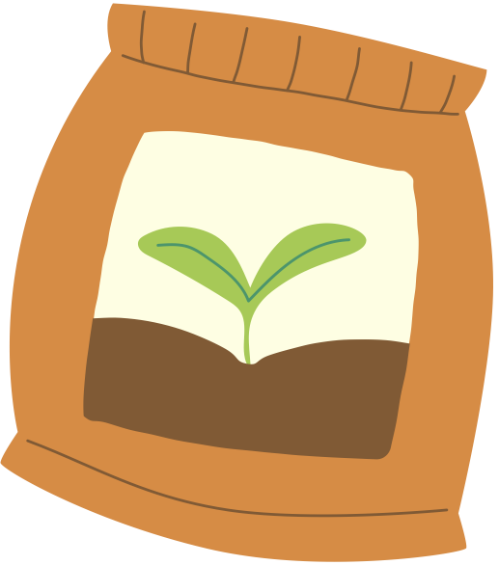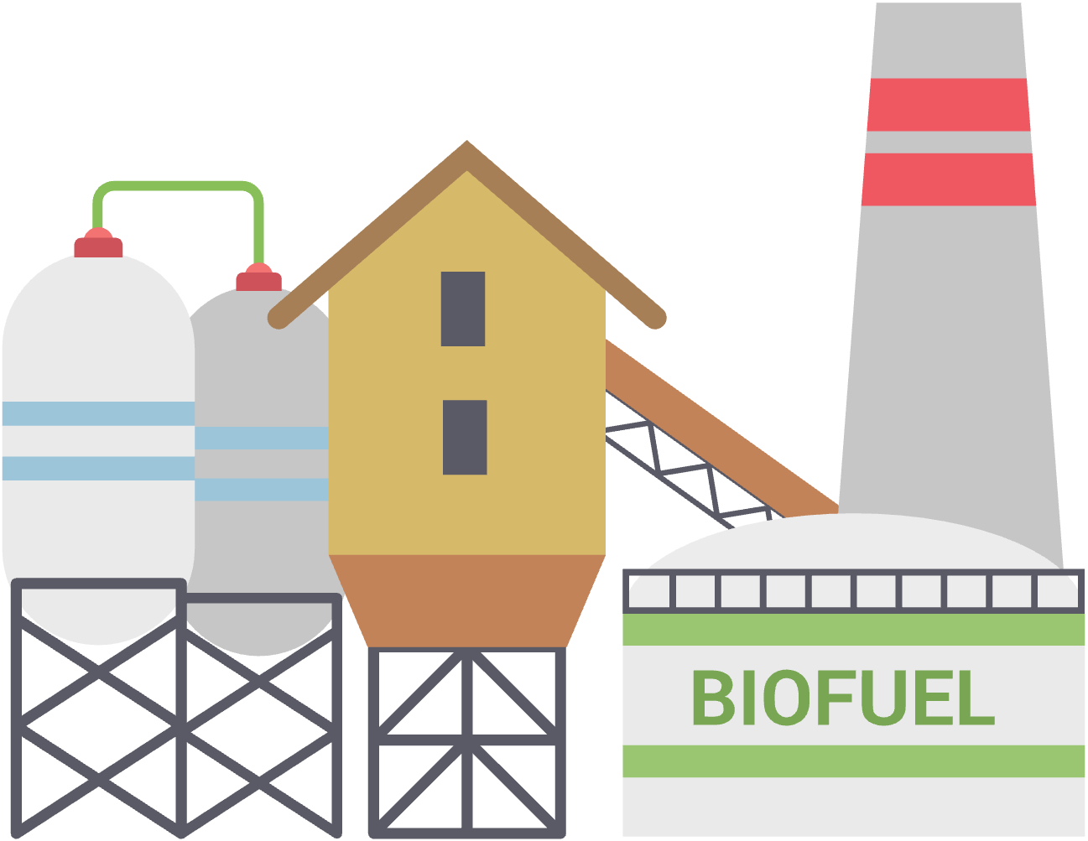

Biogass

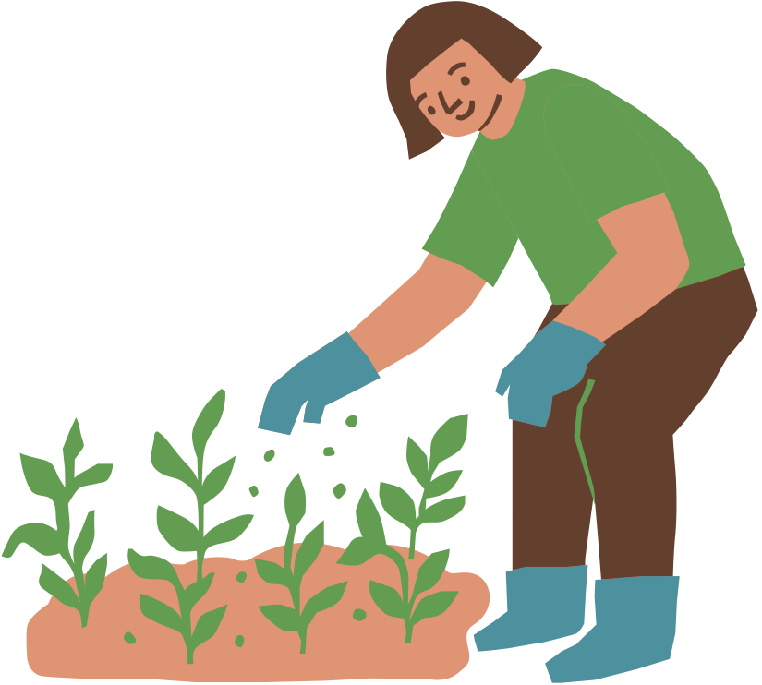

***Technology for Upgrading Organic Fertilisers***

Technologies such as anaerobic digestion, drying, and composting are used to make organic fertilisers. These technologies enhance the quality and effectiveness of the fertilisers, making it more beneficial for agricultural use. Here’s how each technology contributes:

**Anaerobic Digestion - liquid or solid digestate**

* Mechanism: Organic materials (such as manure, food waste, or crop residues) are broken down by microorganisms in the absence of oxygen, producing biogas (methane and carbon dioxide) and digestate (a nutrient-rich residue).
* Benefits:
  + Improved Nutrient Profile: Organic fertiliser from anaerobic digestion is rich in nutrients like nitrogen, phosphorus, and potassium, and often has better nutrient availability compared to the raw organic materials.
  + Reduced Pathogens and Odours: The digestion process helps reduce pathogens and odours, making the fertiliser safe and pleasant to handle.
* Application: Digestate, whether in liquid or solid form, can be applied using the same equipment typically used for spreading manure from dairy or pig farms.

**Drying - granular or pelleted organic fertiliser**

* Mechanism: Organic materials or their by-products (such as composted chicken manure) are dried to reduce moisture content, making them easier to handle and store.
* Benefits:
  + Extended Shelf Life: Dried fertilisers last longer and are less prone to microbial spoilage or degradation during storage.
  + Enhanced Nutrient Concentration: Drying can concentrate nutrients, making the fertiliser more effective per unit of weight.
  + Improved Handling: Dry, granular, or pelleted products are easier to transport, store, and apply than wet or semi-solid organic materials.
* Application: Dried fertilisers can be applied using the same equipment typically used for spreading mineral fertilisers, such as broadcast spreaders

**Composting - organic fertiliser or soil amendment product**

* Mechanism: Organic materials are decomposed by microorganisms in the presence of oxygen, converting them into compost, which is a stable, nutrient-rich soil amendment.
* Benefits:
  + Enhanced Nutrient Availability: Composting stabilises nutrients, making them more available to plants.
  + Improved Soil Structure: Compost improves soil structure, aeration, and water retention, benefiting soil health.
  + Reduction of Pathogens and Weed Seeds: Proper composting processes reduce pathogens and weed seeds, enhancing the safety of the fertiliser.
* Application: Compost can be applied to fields using equipment similar to that used for spreading bedded manure, such as manure spreaders commonly used for sheep and cattle.

***Benefits of upgrading organic fertiliser***

* ***Nutrient-Rich Resource:*** Biological fertilisers like manure contain essential nutrients required for plant growth. However, upgrading these fertilisers can enhance nutrient balance and availability. For example, bio-fertiliser produced from combined digested manure and food waste in a biogas plant often has improved nutrient profiles compared to raw manure alone. This upgraded bio-fertiliser typically offers better nitrogen availability and a more balanced nutrient composition, making it more effective for plant growth.
* ***Carbon and Soil Structure:*** Adding organic material to the soil helps sequester carbon, contributing to climate change mitigation by reducing atmospheric CO2 levels. Biological fertiliser contributes to soil organic carbon stores. Organic matter improves soil structure, water retention, and nutrient availability. Healthy soil leads to increased production and healthier crops.
* **Market Demand:** There is growing consumer and market demand for sustainable and organic farming practices, which can enhance market opportunities for biological-based fertilisers.
* **Reduced Risk of Pollution:** Properly managed biological fertilisers are less likely to cause nutrient runoff and water pollution compared to synthetic alternatives.
* **Lower Carbon Footprint:** Producing and using organic-based fertilisers generally results in lower greenhouse gas emissions compared to synthetic fertilisers.

**Disadvantages**

* **Pathogen Risks**: If not properly processed, upgraded fertilisers may still carry pathogens or weed seeds, though this risk is generally lower with well-managed upgrading processes.
* **Regulations:** There may be regulatory requirements for the use and application of upgraded biological fertilisers, which can vary by region and require adherence to specific standards.
* **Energy Use:** Some upgrading processes, such as those involved drying, require significant energy inputs.
* **Storage Requirements:** Some upgraded biological fertilisers may require specific storage conditions to maintain their effectiveness and prevent degradation.
* **Handling Issues:** Certain forms of upgraded fertilisers, like those in liquid or granular form, might require special equipment for application.
* **Variable Quality:** The nutrient profile of upgraded fertilisers can vary depending on the feedstock and processing methods used
* **Higher Production Costs:** Upgrading processes, such as composting, vermicomposting, or biogas production, can be more expensive than using untreated manure.

**Examples of upgraded biological fertilisers for tomato production**

An example in Norway is Den Magiske Fabrikken (The Magic Factory), which has the capacity to produce approximately 120 GWh of biogas. At the facility, food waste and livestock manure are transformed into biogas, bio-fertiliser, and vermicompost, and green CO2. The food waste comes from approximately 1.2 million residents in Eastern Norway, while the livestock manure is sourced from cattle and pig farms in Vestfold County.

A pilot bubble (BBBLS) greenhouse has been built adjacent to the biogas plant, utilising captured bio-CO2 and dewatered liquid digestate from the biogas plant, along with vermicompost derived from the digestate. The system is called digeponics. Digeponics is a method of agriculture which integrates the organic fertiliser products of anaerobic digestion, including CO2, with greenhouse cultivation of vegetables. This sustainable system produces climate-friendly tomatoes for local supermarkets. The bubble greenhouse technology alone offers an 80% energy saving, and when combined with bio-CO2 and bio-fertiliser use, the greenhouse achieves a remarkable 90% reduction in energy consumption compared to traditional greenhouses.

### Pyrolysis

The Pyrolysis Solution: What Is Pyrolysis?

Pyrolysis is a process where biomass (like wood) is heated to high temperatures—up to 500-600 degrees Celsius—without oxygen (University of Oslo, 2022). Instead of burning, the organic material breaks down into gases, oils, and solid carbon residues. It is a molecular transformation that brings long and complex molecules shorter and to simpler compositions.

*The Logging Dilemma:*

Wood Mass Left Behind: In logging areas, up to half of the wood mass often remains unused.

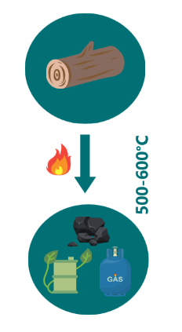

Benefits:

* **Renewable Energy Source:** Forest biomass can be used to generate energy, which is considered renewable and can help reduce reliance on fossil fuels.
* **Reduced Waste:** Using wood residues and other forest by-products for energy helps utilise materials that might otherwise go to waste.
* **Economic Opportunities:** Logging for biomass can provide economic benefits, including job creation in rural areas and support for the forest industry.

Challenges**:**

* **Ecosystem Impact:** Logging can disrupt ecosystems, harm wildlife habitats, and lead to loss of biodiversity. Sustainable management practices are needed to mitigate these effects.
* **Carbon Emissions**: While biomass is renewable, the process of logging and transporting wood can release carbon dioxide and other greenhouse gases. This can offset some of the climate benefits of using biomass for energy.
* **Land Use Change:** Converting forests to biomass production can lead to deforestation or degradation of land, impacting carbon storage and soil health.
* **Sustainability:** Ensuring that logging is done sustainably and does not lead to overharvesting or depletion of forest resources is a key concern.

In essence, "The Logging Dilemma" highlights the need for careful management and policies to address the competing demands of energy production and forest conservation.

Biochar is a porous, carbon-rich material made from renewable sources such as wood and plants. Unlike conventional coal, which is non-renewable, biochar resembles nature’s sponge with its tiny holes and pores.

*Terra Preta*

In the Amazon, ancient soil known as “Terra Preta” was enhanced with biochar, showing its historical importance in soil enrichment (Pommeresche, 2018). The porous structure of biochar helps retain water effectively, creating favourable conditions for plant growth. It also stores nutrients and supports microorganisms that contribute to soil health. Additionally, biochar plays a significant role in carbon sequestration by storing CO₂. Adding one cubic metre of biochar to soil can prevent the emission of 1000 kg of CO₂ (Jære, 2017).

*Energy Production:*

Biochar also has applications in energy production. It can replace less eco-friendly energy sources and is used as fuel in power plants, industrial facilities, and households for heat and electricity. As a carbon-neutral material, biochar is produced from plants that have absorbed CO₂ through photosynthesis.

Bio-Oil: - *Pyrolysis Origins:*

Bio-oil is produced through pyrolysis and is a dark brown liquid containing water, organic compounds like phenols, aldehydes, and ketones, and small amounts of non-condensable gases. The exact composition varies depending on the pyrolysis temperature (O’toole & Grønlund, 2012).

*Bio-Oil Applications:*

* Energy Source: Bio-oil can be used for heating buildings or in power generation to produce electricity. It’s an alternative to traditional fossil fuels.
* Refining Possibilities: Through further refining, bio-oil becomes suitable for the transportation sector.
* Culinary Adventures: Ever heard of “liquid smoke”? It’s a flavouring made from bio-oil, adding a smoky taste to food.

*Bio-Oil Advantages:*

* Bio-oil can be produced from various biomass sources. This flexibility ensures a diverse range of raw materials.
* Bio-oil production is energy-efficient, minimising energy losses. It can seamlessly integrate into existing infrastructure (like oil refineries) (Opdal & Hojem, 2007).

*Bio-Oil Disadvantages:*

* Storage and Handling: Bio-oil has a high water content and can be corrosive, requiring special handling and storage considerations.
* Energy Density: Its energy density is lower compared to conventional fossil fuels, which can limit its use in some applications

### Gasification

**Gasification** is a thermochemical process that converts organic or carbon-containing materials, such as woody biomass (700-800°C), into a mixture of gases known as syngas (synthesis gas). This process occurs at high temperatures in a controlled environment with limited oxygen or steam. The main components of syngas are carbon monoxide (CO), hydrogen (H₂), carbon dioxide (CO₂), and sometimes methane (CH₄).

The Historical Context: Gasification’s Roots

Gasification isn’t a new technology—it has a rich history. Back in the 1800s, gas was used for street lighting in cities. During World War II, wood gas fuelled cars due to petroleum shortages in Europe (Hofstad, 2020).

The Gasification Process: What Is Gasification?

It converts biomass solid or liquid fuels into gas—specifically, syngas (a mixture of hydrogen, carbon monoxide, and other gases). The technology is called a gasifier, the biomass is heated to around 800-1000 degrees Celsius without oxygen and gas is produced.

*Resource Variety:*

Gasification is versatile in its resource usage and can handle a wide range of materials, including:

* Biomass (like wood, bark, and chips)
* Coal
* Natural gas
* Organic waste materials

*Advantages:*

* Reduced Hazardous Emissions: Gasification minimises emissions of harmful substances like sulphur and chlorine (Hofstad, 2020). These get captured in the ash, keeping our air cleaner and reducing acid rain risks.
* Smart Resource Use: Gasification transforms waste (both biological and fossil) into gas. It’s like turning trash into treasure—reducing reliance on fossil fuels and promoting sustainability.
* Preserving Recyclable Metals: Unlike high-temperature processes that harm metals, gasification preserves recyclable materials. Valuable metals can be reused without destruction.

*Disadvantages:*

* Low Energy Density: Gasification’s energy efficiency hovers around 55 percent (Fornybarklyngen, 2020). A significant portion of input energy is lost, requiring larger gas production for desired output.
* Complexity: Waste is a mixed bag of substances, affecting gasification efficiency. Preprocessing or sorting waste may be necessary (Hofstad, 2020).

‘



**800 - 1000°C**

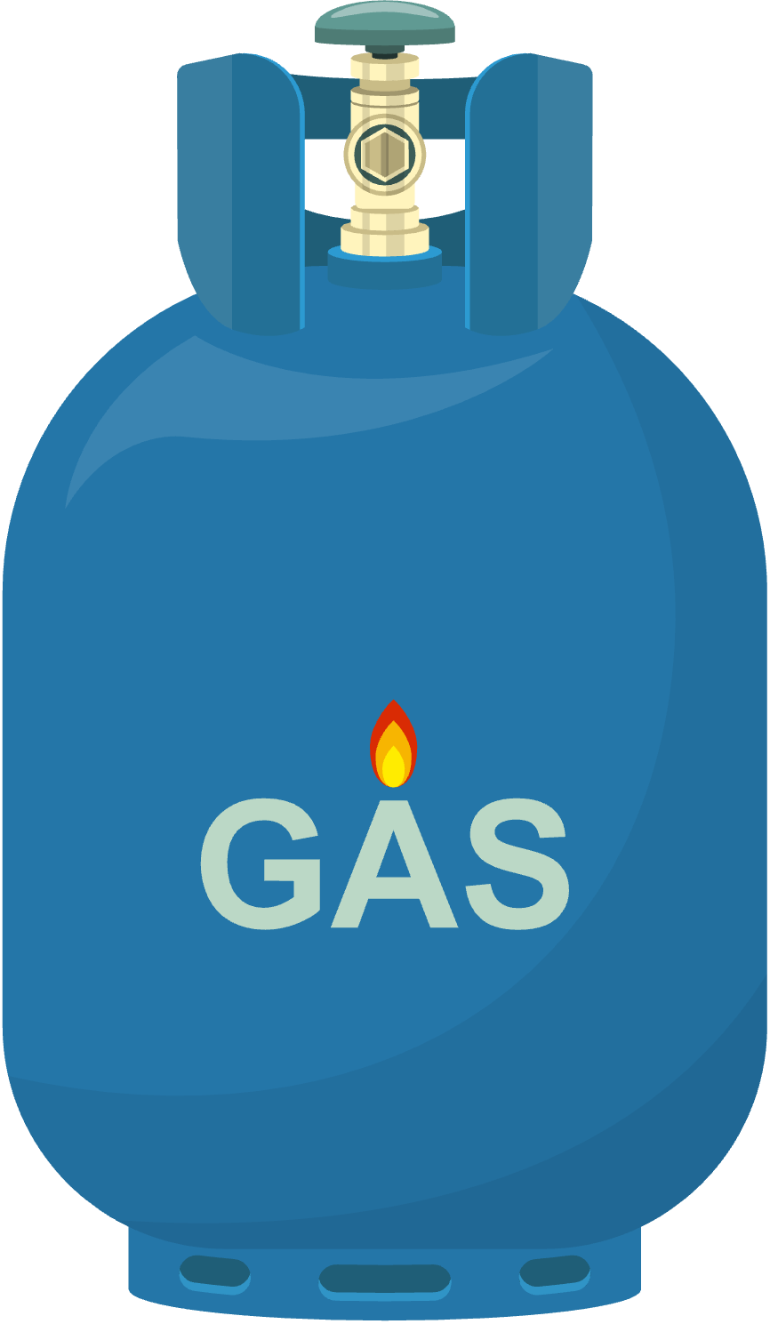

*Gasification difference from Pyrolysis:*

* **Product:** Gasification produces only syngas, while pyrolysis yields bio-oil, charcoal, and a smaller gas fraction.
* **Temperature:** Gasification requires higher temperatures (800-1000°C), whereas pyrolysis occurs at lower temperatures (500-600°C).
* **Resource Range:** Gasification can handle a diverse range of resources, while pyrolysis is typically limited to biomass and organic waste.

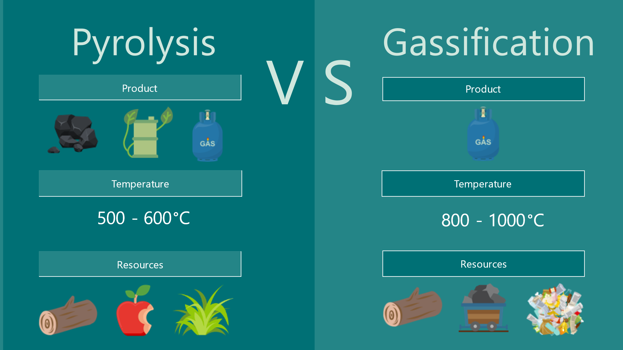

Different types of thermochemical conversion processes for biomass (Mishra & Upadhyay, 2021)

|  |  |  |  |
| --- | --- | --- | --- |
| Route | Temperature (C) | Pressure (MPa) | Main Products |
| Torrefaction | 230-300 | 0.1 | Solid fuels |
| Liquefaction | 250-330 | 5–20 | Bio-oils, Gases |
| Pyrolysis | 300-600 | 0.1–0.5 | Bio-oils, Transport Fuels |
| Gasification | 700-1300 | ≥0.1 | Syngas |
| Combustion | 700-1400 | ≥0.1 | Heat, Electricity |

### Protein Extraction

Protein Extraction through Thermal Hydrolysis: Unlocking Nature’s Building Blocks

*The Basics of Protein Extraction: Why Extract Proteins?*

Proteins are essential for life—they’re the building blocks of cells, tissues, and enzymes. Protein extraction allows us to harness these valuable molecules for various purposes.

 Raw Materials and Methods:

We can extract proteins from diverse sources containing protein:

* Grass
* Animal by-product
* Beans

Different technologies are used like:

**Water-based extraction:** The simplest method where proteins are extracted by mixing plant material with water, often with pH adjustments. After filtration and centrifugation, proteins are separated from the rest of the plant components.

**Alkaline extraction and isoelectric precipitatio**n: In this method, the pH is adjusted to an alkaline level to dissolve proteins from the plant material. The pH is then lowered to the protein's isoelectric point, where it precipitates and can be isolated.

**Enzymatic hydrolysis:** Enzymes are used to break down the cell walls of the plant material, releasing the proteins. This provides a gentler process and helps preserve the functionality of the proteins.

**Thermal hydrolysis:** Involves the use of heat and pressure to break down complex organic molecules, such as proteins, into smaller units. In the context of plant protein extraction, thermal hydrolysis can help break down the cell walls of plant material and release proteins. It can be beneficial for increasing protein yield or improving the digestibility of the proteins. However, it is important to balance the heat and pressure to avoid denaturation of the proteins, which can reduce their functional properties in food prod

*Thermal Hydrolysis Demystified: What Is Thermal Hydrolysis?*

Imagine heating grass (or any other raw material) and then pressing it to extract liquid. This liquid contains proteins—the gems we’re after! The remaining grass splits into two parts: a wet portion and a solid part.

*Processing the Solid Remnants:*

Depending on our goal, we can process the solid remnants in several ways:

1. **Drying:** By removing the moisture from the remnants, we obtain a stable, dry product in the form of powder or pellets. This method helps preserve the protein content for longer-term storage and makes it easier to transport.
2. **Liquid Solution:** Sometimes, the liquid byproduct containing proteins is more valuable in its wet form. This solution can be used directly in some applications or can undergo further processing to isolate specific protein fractions or nutrients.

*Versatile Applications:*

Protein-rich byproducts from plants can be harnessed to create a new generation of plant-based food products for both people and animals.

* **Meat Substitutes:** With the growing demand for alternatives to animal-based products, plant proteins from remnants offer a promising solution. These proteins can be formulated into textured meat substitutes that mimic the taste and texture of traditional meat.
* **Protein-rich Bars and Snacks:** Imagine creating bars and snacks that are not only high in protein but also derived from sustainable sources like grass or other plant remnants!
* **Animal feed:** Proteins are also vital for the health and growth of livestock. By incorporating plant-derived protein byproducts into animal feed, we can enhance the nutrition provided to livestock. Instead of importing soy or other protein sources that have a larger carbon footprint, we could potentially replace them with locally sourced, protein-rich byproducts.

Some companies are developing modular protein extraction systems designed for smaller operations, here is one example:

**Alfa Laval- Plant-based protein processing**

[Alfa Laval](https://www.alfalaval.com/industries/food-dairy-beverage/food-processing/protein-processing/plant-based-protein-processing/)offers smaller-scale plant protein processing systems, suitable for local or farm use. They offer a range of plant-based protein processing systems that are scalable and customizable. Their solutions include protein extraction, separation, and purification, designed to be efficient and sustainable

### 

### Phosphorus recovery

Extracting phosphorus from biological material, such as organic waste, manure, or food waste, has several key benefits, particularly given that phosphorus is a critical nutrient for plant growth. Here are the main reasons for extracting phosphorus from biological material:

* **Phosphorus is a Finite Resource:** Phosphorus, primarily sourced from phosphate rock, is a non-renewable resource that is being depleted. Extracting phosphorus from biological material offers a sustainable way to recycle this vital nutrient and reduce dependence on mined phosphorus.
* **Sustainable Waste Management:** Biological materials like manure, food waste, and sewage contain significant amounts of phosphorus. Extracting it helps to recycle nutrients from waste that would otherwise contribute to pollution. By recovering phosphorus, we reduce waste and the environmental impact of nutrient run-off, which can lead to waterway eutrophication and dead zones.
* **Improving Soil Fertility**: Phosphorus is essential for root development, energy transfer, and overall plant health. Extracting phosphorus from organic materials and adding it back to soils helps replenish nutrient-depleted agricultural soils, maintaining their fertility and productivity over time.
* **Reducing Chemical Fertiliser Use:** Extracting phosphorus from biological material helps reduce the reliance on synthetic chemical fertilisers. This supports more sustainable farming practices and decreases the environmental and economic costs associated with manufacturing and transporting chemical fertilisers.
* **Circular Economy:** By extracting phosphorus from waste materials, the agricultural system becomes more circular. Nutrients are reused, which aligns with the principles of circular agriculture, reducing both waste and the need for external inputs like synthetic fertilisers.
* **Meeting Agricultural Demand:** Phosphorus is one of the primary nutrients needed for food production, and the demand is high. Extracting phosphorus from biological materials provides an alternative supply to meet the growing demand for phosphorus in agriculture, especially as global food production needs continue to rise.

In summary, phosphorus extraction from biological material promotes sustainability, reduces environmental harm, and supports agricultural productivity in a more circular and resource-efficient manner

There are several technologies for phosphorus recovery and two technologies are presented.

Given that phosphorus reserves in the world are extremely limited, technologies for recovery are significantly important. Moreover, current phosphorus sources are increasingly contaminated and are located in hard-to-reach places like China, Morocco, and Russia which means that phosphorus is of geopolitical concern.

The [European Sustainable Phosphorus Platform](https://www.phosphorusplatform.eu/), provides success stories for recovery of phosphate from agriculture by-products and waste streams like biosolid and sewage. There are many technologies for Recovery of Phosphorus, according to the European phosphorus platform some of them are:

|  |  |  |
| --- | --- | --- |
| [Anuvia Plant Nutrients](https://www.phosphorusplatform.eu/activities/p-recovery-technology-inventory?view=article&id=2319:anuvia&catid=93:nutrient-recovery-technology-catalogue) | [Metawater alkaline ash leaching](https://www.phosphorusplatform.eu/activities/p-recovery-technology-inventory?view=article&id=2291:metawater&catid=93:nutrient-recovery-technology-catalogue) | [RSR (Green Sentinel)](https://www.phosphorusplatform.eu/activities/p-recovery-technology-inventory?view=article&id=2335:rsr-green-sentinel&catid=93:nutrient-recovery-technology-catalogue) |
| [Ash2Phos (EasyMining)](https://www.phosphorusplatform.eu/activities/p-recovery-technology-inventory?view=article&id=2284:ash2phos&catid=93:nutrient-recovery-technology-catalogue) | [NuReSys](https://www.phosphorusplatform.eu/activities/p-recovery-technology-inventory?view=article&id=2292:struvite-precipitation&catid=93:nutrient-recovery-technology-catalogue) | [Rubiphos-TTBS](https://www.phosphorusplatform.eu/activities/p-recovery-technology-inventory?view=article&id=2543:rubiphos&catid=93:nutrient-recovery-technology-catalogue) |
| [AshDec (Metso Outotec)](https://www.phosphorusplatform.eu/activities/p-recovery-technology-inventory?view=article&id=2316:ashdec&catid=93:nutrient-recovery-technology-catalogue) | [P-roc](https://www.phosphorusplatform.eu/activities/p-recovery-technology-inventory?view=article&id=2334:proc&catid=93:nutrient-recovery-technology-catalogue) | [SIMPhos-process (Cirkel)](https://www.phosphorusplatform.eu/activities/p-recovery-technology-inventory?view=article&id=2338:simphos&catid=93:nutrient-recovery-technology-catalogue) |
| [Charlene - ReCord](https://www.phosphorusplatform.eu/activities/p-recovery-technology-inventory?view=article&id=2576:proc&catid=93:nutrient-recovery-technology-catalogue) | [PAKU (Endev)](https://www.phosphorusplatform.eu/activities/p-recovery-technology-inventory?view=article&id=2296:paku-endev&catid=93:nutrient-recovery-technology-catalogue) | [Sinfert](https://www.phosphorusplatform.eu/activities/p-recovery-technology-inventory?view=article&id=2567:sinfert&catid=93:nutrient-recovery-technology-catalogue) |
| [Ecophos, EcophosLoop (Prayon)](https://www.phosphorusplatform.eu/activities/p-recovery-technology-inventory?view=article&id=2328:prayon&catid=93:nutrient-recovery-technology-catalogue) | [Parforce](https://www.phosphorusplatform.eu/activities/p-recovery-technology-inventory?view=article&id=2327:parforce&catid=93:nutrient-recovery-technology-catalogue) | [Sludge lysis](https://www.phosphorusplatform.eu/activities/p-recovery-technology-inventory?view=article&id=2294:sludge-lysis-thp&catid=93:nutrient-recovery-technology-catalogue) |
| [EuPhore](https://www.phosphorusplatform.eu/activities/p-recovery-technology-inventory?view=article&id=2287:euphore&catid=93:nutrient-recovery-technology-catalogue) | [Pearl (Ostara)](https://www.phosphorusplatform.eu/activities/p-recovery-technology-inventory?view=article&id=2292:struvite-precipitation&catid=93:nutrient-recovery-technology-catalogue) | [Spodofos (ThermusP)](https://www.phosphorusplatform.eu/activities/p-recovery-technology-inventory?view=article&id=2337:spodofos&catid=93:nutrient-recovery-technology-catalogue) |
| [Flashphos (Uni. Stuttgart, Italmatch)](https://www.phosphorusplatform.eu/activities/p-recovery-technology-inventory?view=article&id=2333:flashphos&catid=93:nutrient-recovery-technology-catalogue) | [PHOS4Green (Glatt)](https://www.phosphorusplatform.eu/activities/p-recovery-technology-inventory?view=article&id=2290:phos4green-glatt&catid=93:nutrient-recovery-technology-catalogue) | [Struvite enhanced: Return streams](https://www.phosphorusplatform.eu/activities/p-recovery-technology-inventory?view=article&id=2293:struvite-precipitation-enhanced&catid=93:nutrient-recovery-technology-catalogue) |
| [GetMoreP (Prayon)](https://www.phosphorusplatform.eu/activities/p-recovery-technology-inventory?view=article&id=2560:prayong2&catid=93:nutrient-recovery-technology-catalogue) | [Phos4Life (ZAR – Técnicas Reunidas)](https://www.phosphorusplatform.eu/activities/p-recovery-technology-inventory?view=article&id=2312:tecnicas-reunidas&catid=93:nutrient-recovery-technology-catalogue) | [Struvite enhanced: acid (MSE-mobile)](https://www.phosphorusplatform.eu/activities/p-recovery-technology-inventory?view=article&id=2363:ALIAS&catid=93:nutrient-recovery-technology-catalogue) |
| [HAIX ion exchange (LayneRTTM)](https://www.phosphorusplatform.eu/activities/p-recovery-technology-inventory?view=article&id=2359:haix-ion-exchange-laynert&catid=93:nutrient-recovery-technology-catalogue) | [PHOSPHIX (Clean TeQ Water)](https://www.phosphorusplatform.eu/activities/p-recovery-technology-inventory?view=article&id=2339:phosphix&catid=93:nutrient-recovery-technology-catalogue) | [Struvite precipitation](https://www.phosphorusplatform.eu/activities/p-recovery-technology-inventory?view=article&id=2292:struvite-precipitation&catid=93:nutrient-recovery-technology-catalogue) |
| [HTCycle](https://www.phosphorusplatform.eu/activities/p-recovery-technology-inventory?view=article&id=2344:htcycle&catid=93:nutrient-recovery-technology-catalogue) <https://www.phosphorusplatform.eu/activities/p-recovery-technology-inventory?view=article&id=2284:ash2phos&catid=93:nutrient-recovery-technology-catalogue> | [Phosphogreen (Suez)](https://www.phosphorusplatform.eu/activities/p-recovery-technology-inventory?view=article&id=2292:struvite-precipitation&catid=93:nutrient-recovery-technology-catalogue) | [SusPhos](https://www.phosphorusplatform.eu/activities/p-recovery-technology-inventory?view=article&id=2336:susphos&catid=93:nutrient-recovery-technology-catalogue) |
| [ICL](https://www.phosphorusplatform.eu/activities/p-recovery-technology-inventory?view=article&id=2351:metawater&catid=93:nutrient-recovery-technology-catalogue) | [Phosphorce (Veolia)](https://www.phosphorusplatform.eu/activities/p-recovery-technology-inventory?view=article&id=2293:struvite-precipitation-enhanced&catid=93:nutrient-recovery-technology-catalogue) | [TerraNova (HTC)](https://www.phosphorusplatform.eu/activities/p-recovery-technology-inventory?view=article&id=2288:terranova-htc&catid=93:nutrient-recovery-technology-catalogue) |
| [Kemira iron / aluminium phosphate](https://www.phosphorusplatform.eu/activities/p-recovery-technology-inventory?view=article&id=2315:kemira-fe-al&catid=93:nutrient-recovery-technology-catalogue) | [RAVITA (Helsinki HSY)](https://www.phosphorusplatform.eu/activities/p-recovery-technology-inventory?view=article&id=2297:ravita-helsinki-hsy&catid=93:nutrient-recovery-technology-catalogue) | [TetraPhos (Remondis)](https://www.phosphorusplatform.eu/activities/p-recovery-technology-inventory?view=article&id=2286:tetraphos-remondis&catid=93:nutrient-recovery-technology-catalogue) |
| [Kubota](https://www.phosphorusplatform.eu/activities/p-recovery-technology-inventory?view=article&id=2289:kubota&catid=93:nutrient-recovery-technology-catalogue) | [Renewable Nutrients](https://www.phosphorusplatform.eu/activities/p-recovery-technology-inventory?view=article&id=2295:renewable-nutrients-quickwash&catid=93:nutrient-recovery-technology-catalogue) | [Varcor](https://www.phosphorusplatform.eu/activities/p-recovery-technology-inventory?view=article&id=2394:varcor&catid=93:nutrient-recovery-technology-catalogue) |
| [LYSTEK](https://www.phosphorusplatform.eu/activities/p-recovery-technology-inventory?view=article&id=2350:LYSTEK&catid=93:nutrient-recovery-technology-catalogue) | [RePeat (Nijhuis Saur Industries)](https://www.phosphorusplatform.eu/activities/p-recovery-technology-inventory?view=article&id=2342:repeat-2&catid=93:nutrient-recovery-technology-catalogue) | [ViviMag® (Kemira)](https://www.phosphorusplatform.eu/activities/p-recovery-technology-inventory?view=article&id=2313:vivimag&catid=93:nutrient-recovery-technology-catalogue) |
|  |  | [WasStrip (Ostara)](https://www.phosphorusplatform.eu/activities/p-recovery-technology-inventory?view=article&id=2293:struvite-precipitation-enhanced&catid=93:nutrient-recovery-technology-catalogue) |

There are different technologies and management systems for phosphor recovery. The two pathways that are present are formation of struvite and recovery of phosphorus from ash.

- Phosphorus source for Sustainable Agriculture**

*What is Struvite?*

Struvite is a mineral that forms when specific substances—ammonium, phosphate, and magnesium—come together in a liquid blend. Imagine tiny crystals resembling sand or small stones.

*The Problem:*

Struvite can wreak havoc in pipes and sewage systems, causing blockages and disruptions (Blytt, 2022).

*Struvite Extraction Process:*

* Collection and Formation: We start by collecting wastewater containing struvite. Next, we add specific chemical substances to help form struvite crystals. These crystals contain essential nutrients: phosphorus, nitrogen, and magnesium.
* Separation and Isolation: Once the struvite crystals have formed, we separate them from the liquid.
* Filtration or settling allows us to isolate the struvite crystals.
* Fertiliser Potential: These isolated struvite crystals are ready to be used as fertiliser. They’re rich in phosphorus—a critical nutrient for plant growth.

*Advantages of Struvite Extraction:*

1. Preserving Valuable Phosphorus: Phosphorus is a limited resource, and struvite helps us utilise it better. By extracting struvite, we ensure a sustainable supply for agriculture.
2. Water Environment Protection: Excessive phosphorus in water leads to rapid algae growth, disrupting ecosystems. Struvite removal from wastewater contributes to cleaner water.

Struvite formation will happen and crystallise if you have a liquid with the right temperature, pH and concentration of nitrogen as ammonium nitrogen, magnesium ion and phosphorus as phosphate. To control the crystallisation process different technologies have been evolved and are available in the market. Usually, you must control the balance of the ions NH4+, PO4 2-and Mg2+, and often magnesium must be added to get the right conditions.

Dairy Research Farm **De Marke** in the Netherlands has implemented struvite recovery technology in its bio-refinery. Several other wastewater treatment plants, such as the **Waßmannsdorf facility** in Berlin, have also installed similar systems like AirPrex® to recover struvite from wastewater sludge / biosolid treatment. This helps in reducing phosphate levels in wastewater while producing a marketable fertiliser​.

**Extraction of phosphorus from ash**

EasyMining focuses on phosphorus recovery, addressing Europe’s heavy reliance on mined phosphorus (Blytt et al., 2017). Their Ash2®Phos technology extracts phosphorus from sewage sludge ash after incineration. Up to 90% of phosphorus can be reclaimed from this ash (EasyMining, 2023).

*Three-Step Process:*

* Acidic Step: Dissolve phosphorus from the ash using acid, yielding a phosphorus-rich intermediate product.
* Alkaline Step: Stabilise the intermediate product for further processing.
* Conversion Step: Create a user-friendly phosphorus product for agricultural use.

EasyMining’s technology utilises waste as a resource. It not only retrieves phosphorus but also other valuable metals (EasyMining, 2023). In partnership with Gelsenwasser, EasyMining will build the world's first phosphorus recovery plant using the Ash2Phos technology in Germany. Set to start operations in early 2027. The technology will provide circular phosphorus to be used in fertilisers.

### Nitrogen recovery

**Plasma treatment - nitrogen enhancement**

The production of mineral fertilisers is facing sustainability issues. The raw materials are finite, and the manufacturing process relies on fossil fuels, which are detrimental to the climate. Hence, it’s crucial to explore innovative and eco-friendly methods for producing fertilisers that can provide necessary nutrients without harming our environment.

N2Applied has developed a groundbreaking technology to reduce nitrogen oxide emissions, a powerful greenhouse gas. This innovation allows farmers to lower their environmental impact, making agriculture more sustainable and efficient. By converting atmospheric nitrogen (N2), which plants cannot use, into ammonium nitrate, it provides crops with an accessible and valuable nutrient. The technology primarily comprises three components: a power supply, a plasma unit, and an absorption tower. The process involves separating nitrogen from the air and combining it with water to create a liquid fertiliser. What sets N2Applied’s technology apart is its ability to produce fertiliser on-site, such as on a farm. This eliminates the need for transportation and gives farmers greater control over production. The technology also aids in reducing nitrogen oxide emissions, benefiting the environment and climate.

The technology N2Applied is currently applied at ten sites in six different European countries.

**Norway:** N2 Unit was installed at the farm in Røros, treating slurry from the farm’s 130 dairy cows. The installation at Galåvolden Gård utilises locally produced energy generated from solar panels.

**Denmark:** The plant in Foulum consists of four reactors of 15 L, four reactors of 200 L, two reactors of 10 m3, two reactors of 30 m3 and the main digester of 1200 m3 with the capacity to treat approximately 80 tonnes of raw materials daily. The N2 Unit at AU Foulum is currently treating a fraction of the total digestate generated.

**Sweden:** More Biogas, Småland was established in February 2011 as a fermentation plant, producing compressed vehicle fuel for local use in Kalmar, Sweden. The company has 22 co-owners of which 18 are nearby chicken, pig and cow farmers in Förlösa, Läckeby and Rockneby just north of Kalmar.

Approximately 90,000 tonnes of substrate is transported to the facility yearly. With substrate being made up of manure supplied from the farms, along with food waste from households in the neighbouring municipalities. In a collaborative exchange agreement with the supplying farmers, this slurry has since been transported on average 7.5km from the plant and spread onto the fields of the supplying farmers, equating to approximately 3,500 hectares of land. By integrating N2’s plasma technology into More Biogas’ existing infrastructure in 2021, allows the digestate by-product to be treated, generating a high-performance organic fertiliser.

**Recover ammonium nitrogen - scrubbing technology**

Ammonia nitrogen can be recovered from liquid by raising the pH by lye, which converts ammonium into ammonia gas. The ammonia is then washed with an acid to convert it back into forms such as ammonium nitrate or ammonium sulphate. This technology is used in wastewater treatment plants and one example is from a Finnish biogas plant for treatment of sewage sludge and biowaste.

Example from Finland

The Forssa energy production plant in Finland, now called Sallia Energia since July 2024 – is one of over 130 such sites owned and operated by Nevel. They generate 190 GWh of energy a year using solid bioenergy as its main fuel however wastewater sludge and food waste and animal by-product. The produced biogas is partly used for water vapour production, necessary for the technological process, part is used to produce electricity and heat in a combined heat and power plant part of the biogas is additionally purified and enriched biomethane, which is sold at a nearby biomethane filling station (compressed biogas). During the agricultural season, bio-fertiliser is given free of charge to nearby farms as fertiliser. During the winter period, the dry matter fraction is separated from the digested substate with the help of centrifuges and stored until the spring and the agricultural season and sent to the farmers. The liquid fraction (reject water) is additionally treated with lye (Na alkali) degrading the remaining soluble organic matter, then with sulfuric acid to produce ammonium sulphate. The latter process separates ammonium and nitrate from the rejected water.

# **Part II: Implementation and Solutions**

## Key Challenges to Innovation and Creation

Innovation and new creations within the bioeconomy face specific challenges. Here are some of the main key challenges:

### Technological development

A challenge within the bioeconomy is to develop and improve technologies that enable efficient utilisation of organic material and recycling of nutrients. This may include technologies for biomass energy conversion, biotechnology to optimise production processes, and methods for recycling and recovery of nutrients. Development and implementation of new technologies requires significant research, investment and testing.

*Example:*

Development of more cost-effective and sustainable methods for biomass conversion, for example in the production of bioethanol from cellulose materials. The challenge lies in finding optimal processes that balance energy consumption and production costs.

### Market and financial uncertainty

The bioeconomy is constantly developing, and there is often uncertainty related to market opportunities and financial profitability. Bioeconomic products and services can face challenges with demand, price and competition from established industries.

* Example: While bioplastics can be an environmentally friendly substitute for traditional plastics, the price can be higher, which can reduce demand (Fredi & Dorigato, 2021).

### Sustainability and environmental impact

The bioeconomy faces challenges related to sustainability and environmental impact. It is necessary to ensure that the production and use of organic material takes place in a sustainable way that considers environmental consequences, such as deforestation, water consumption, chemicals and emissions of greenhouse gases.

* Example: Increased use of organic material can lead to conflicts between the need for food production and the production of raw materials for bio-economic products. For example, increased demand for biofuels can lead to competition for agricultural land for food production. Organic material production can also affect local ecology and biodiversity. Deforestation to obtain organic material can lead to loss of habitat for endangered species and changes in ecosystems.

### Political and regulatory framework conditions

The bioeconomy operates within a complex set of political and regulatory framework conditions. Challenges can arise in the form of a lack of harmonisation of regulations, unclear regulations for bioeconomy products, and lack of incentives for a sustainable bioeconomy (Olsen & Torrissen, 2023).

* Example: There are statutory restrictions relating to the use of sewage sludge-based bio-fertiliser. The seaweed and kelp industry and the insect industry are also struggling to establish themselves due to limitations in the legislation relating to product definitions.

To address these challenges, collaboration between academia, industry, authorities and society in general is necessary. Investments in research and development, design of supporting policy and regulation, awareness of sustainability and environmental impact, and measures to promote knowledge and competence within the bioeconomy are required.

### Global and European Policy

Here are some quick facts about the political strategies connected to achieving a more sustainable future and where the bioeconomy plays a role. If you want to engage students with quizzes and games, [the EU’s learning corner](https://learning-corner.learning.europa.eu/learning-materials/2050-its-you_en) offers many interactive activities, which you can pick and choose from.

Let’s ask the students: Do you think we will achieve the goals by 2050?

Imagine it is 2030 and you have your own business in the green sector. What are you prepared to do to contribute to the goals? Perhaps produce renewable energy? Work with researchers to test new innovative technologies? Collect your waste to be later transformed into new products? Plant a garden that gives shelter and food to pollinators?

Now let’s gain some more knowledge.

The Paris Agreement:

A treaty combating climate change. It aims to limit global temperature rise to well below 2°C above pre-industrial levels. Every signatory country works toward agreed-upon goals. For example, Sweden pledged to become carbon-neutral (have net-0 emissions) by 2045. Finland is one of Europe’s most ambitious countries, wanting to achieve climate neutrality by 2035. (Ministry of Foreign Affairs in Finland). Almost the entire world is working towards achieving climate neutrality by 2050, the only countries that have not signed the Paris Agreement are Iran, Libya and Yemen.

The EU Green Deal

[First, we can watch an explanatory video](https://www.youtube.com/watch?v=H37grur6HaU).

To meet such important goals, more strategies and concrete plans are needed at the European, National and local levels. To have a common vision, the EU parliament voted to pass the EU Green Deal in 2021 which is a document that lays out how to achieve climate neutrality by 2050. It is a roadmap for transforming the EU’s economy, with actions to boost the efficient use of resources by moving to a clean, circular economy and restore biodiversity and cut pollution.

The Green Deal has several key objectives:

* Climate Neutrality: The EU aims to reach net-zero greenhouse gas emissions by 2050. This means balancing the amount of emitted greenhouse gases with the amount taken out of the atmosphere.
* Clean Energy: The plan includes a strategy for a more sustainable energy sector, with a greater focus on renewable energy sources and an aim to achieve energy efficiency.
* Sustainable Industry: The EU plans to support industry to innovate and become global leaders in the green economy. This includes promoting cleaner technologies and processes.
* Building and Renovating: The EU aims to improve energy efficiency in buildings and reduce their carbon footprint through renovation and design improvements.
* Zero Pollution: The goal is to prevent and reduce pollution of air, water, and soil to ensure a toxic-free environment.
* Biodiversity: The EU plans to protect and restore ecosystems and biodiversity, both on land and in the ocean.

The EU Circular Economy Action Plan (CEAP) is part of the European Green Deal. It plans to:

* Transition to a circular economy for sustainable growth.
* Reduce pressure on natural resources and halts biodiversity loss.

### The impact of bioeconomy on society and environment

Bioeconomy and Jobs

The bioeconomy generates over 17 million jobs in the EU. It represents 4.7% of the EU’s GDP and 8.3% of its labour force at the time of writing. It has positive spill-over effects throughout the value chain. It benefits both urban and rural areas, for example:

* Rural Revitalization: The bioeconomy can stimulate rural economies by creating demand for locally sourced biological resources.
* Sustainable Agriculture and Forestry: Bioeconomic practices promote sustainable agriculture and forestry, contributing to the preservation and enhancement of natural resources in rural areas.
* Community Empowerment: By creating jobs and stimulating economic activity, the bioeconomy can empower rural communities, reducing rural-urban disparities.

The circular bioeconomy draws a path to resilience and is directly impacting in slowing down climate change, which impacts on our security and health.

But who is going to build it and how can small farmers contribute? Sure, big investments can be made that small farming communities often cannot afford. But that hasn’t stopped communities from contributing to, for example, increasing Europe’s share of clean renewable energy.

[Take a look at how this has developed in Europe.](https://www.youtube.com/watch?v=ZTmeNmWEupg)

Many have turned to the term known as energy democracy. Energy democracy means that a community invests together in building a shared energy production facility, for example as a cooperative. Take for example a farming community that wants to utilise their waste on the farm in a better way, but they live far from a town that has a biogas plant. They pool resources together to build a bigger biogas plant together in their area and have shared ownership.

### The climate benefit of using biogas and bio-fertiliser

Climate benefit involves reducing greenhouse gas emissions. Measures like transitioning to renewable energy and conserving forests contribute to limiting global warming and mitigating climate change.

**Economic Advantages:**

* Developing green technologies and renewable energy sources creates new jobs and stimulates economic growth.
* Reducing dependence on costly and harmful resources benefits both the environment and the economy.
* Energy efficiency and climate adaptation can also reduce costs related to energy consumption and infrastructure.

**Social Well-Being:**

Climate benefits extend to people’s health and quality of life.

* Reducing air pollution from greenhouse gases decreases respiratory diseases.
* Climate adaptation protects vulnerable communities, helping them maintain livelihoods and community resilience.

**Balancing Costs and Benefits:**

While addressing climate change can be expensive, the long-term benefits create a more sustainable and resilient society.

**Environmental impact of utilising biogas and fertiliser**

Let’s take Norway as an example.  Climate benefit is expressed as a percentage. Investing in biogas can yield a climate benefit of over 100 percent (Pederstad, 2017).

Example Illustration:

Imagine a vehicle emitting 100 tons of CO2 equivalents using regular gasoline. If we replace gasoline with biogas and reduce emissions by 100 tons of CO2 equivalents, we achieve 100 percent climate benefit. In other words, we’ve eliminated or reduced greenhouse gas emissions equivalent to the fossil fuel reference point.

Triple Climate Benefit:

Biogas not only reduces emissions but also contributes to:

* Nutrient recycling
* Capture of harmful greenhouse gases like methane

These combined effects can provide more than 200 percent climate benefit compared to regular fossil fuels (EU, 2018).

Reasons for High Climate Benefit:

Let’s break it down into four main parts:

* Replacing Fossil Energy Carriers: Biogas prevents methane emissions and replaces fossil fuels, reducing CO2 emissions from combustion (Pederstad 2017).
* CO2 Upgrading: Biogas-derived CO2 replaces fossil-based CO2.
* Biorefinery Residues: Biogas can replace mineral fertilisers.
* Waste and Manure Treatment: Biogas plants have lower climate impact than alternative handling methods.

### Positive Impact with Increased Production:

The more biogas we produce, the greater the climate benefit. Norway currently produces biogas equivalent to 0.7 TWh (Biogass Oslofjord og Biogass Norge, 2023). Producing 2.8 TWh of biogas could potentially reduce CO2 emissions by around 552,000 tons per year (replacing natural gas) or 716,000 tons (replacing diesel) (Lyng & Berntsen, 2023). This constitutes 6 to 8 percent of national emissions from road transport, depending on the fuel replaced (Lyng & Berntsen, 2023).

1. Replacing Fossil-Based CO2 with Bio-CO2

The CO2 produced during the biogas upgrading process has the potential to replace fossil-based CO2 used in various industries. This bio-CO2 can offer a sustainable alternative, reducing reliance on industrial CO2 derived from fossil fuels.

1. Biogas Digestate as a Sustainable Fertiliser

Biogas digestate, a byproduct of biogas production, efficiently recycles nutrients from organic waste, making it an eco-friendly alternative to chemical fertilisers. The production of chemical fertilisers is energy-intensive and relies on fossil fuels, while biogas digestate not only mitigates environmental harm but also helps reduce nitrous oxide emissions. Additionally, biogas digestate enriches soil with organic carbon, enhancing soil quality and contributing to long-term carbon sequestration.

1. Utilising Waste and Manure in Biogas Plants

In Norway, manure management is a significant source of emissions. Treating livestock manure in biogas plants helps reduce these emissions by shortening storage time, which lowers methane and nitrous oxide emissions. By using manure for biogas production, the country can achieve significant reductions in greenhouse gas emissions—estimated at 55,000 tons of CO2 equivalents by 2030 and 155,000 tons by 2050 (Lyng & Berntsen, 2023)*.*

1. *Optimising Biogas Production for Climate Impact*

To fully realise the climate benefits of biogas, it is essential to streamline production and utilisation. Raw biogas flaring, which involves burning without capturing energy, is a waste of potential. Efficiently managing biogas production ensures that we maximise its contribution to the fight against climate change, making the most of this valuable renewable resource.

### Further possibilities within bioeconomy

**Protein Extraction from Grass: A Sustainable Alternative for Animal Feed**

1. The Challenge: Finding Sustainable Protein Sources

Soybean meal is a widely used protein source in animal feed, but the heavy reliance on imported soy comes with environmental and sustainability issues. The cultivation of soy often leads to deforestation, particularly in rainforests, and creates a dependence on foreign suppliers, posing risks to both ecosystems and food security.

1. The Solution: Biorefining Grass and Clover

To address these challenges, researchers are developing a scalable process for extracting protein from local resources like grass and clover. These crops, harvested from fields or specially planted clover, offer a sustainable alternative. While raw grass contains lignin and cellulose, which are indigestible for non-ruminant animals like pigs and chickens, the biorefining process makes it a viable feed option.

1. The Extraction Process

The process begins by pressing grass to obtain grass juice. This juice is then heated, causing the dissolved proteins to solidify. These solid proteins are filtered out, resulting in a concentrated protein product. This grass protein concentrate can be used as a sustainable ingredient in animal feed.

1. Benefits of Grass Protein

Grass protein concentrate provides a sustainable and locally sourced alternative to soy in animal feed, available in both wet and dry forms. By using grass protein, farmers can reduce their reliance on imported soy, lower their environmental impact, and promote regional self-sufficiency, contributing to a more sustainable and resilient agricultural system.

Agricultural Waste as a Resource

Agricultural waste, often seen as a disposal problem, can be a valuable resource. Crop residues like straw, husks, and stalks are rich in cellulose, a complex carbohydrate that forms the structural component of plant cell walls. These residues can be processed to extract cellulose fibres.

Obtaining Fibres

The process of obtaining fibres from agricultural waste involves several steps. First, the waste is collected and cleaned. It is then subjected to a series of mechanical and chemical treatments to separate the cellulose fibres from other components like lignin and hemicellulose. The resulting cellulose fibres can be used in various applications, including the production of paper, textiles, and bio composites.

Producing Bioplastics

Bioplastics can also be produced from agricultural waste. Starch, a common component of many agricultural residues, can be extracted and processed to produce biodegradable plastics. This involves treating the starch with plasticizers and other additives, and then heating and moulding it into the desired shape. The resulting bioplastic is not only biodegradable but also has a significantly lower carbon footprint compared to conventional plastics.

Agricultural Waste as a Source of Valuable Compounds

Agricultural waste contains valuable compounds. Many types of agricultural waste, such as fruit peels, seed husks, and crop residues, contain bioactive compounds that have potential uses in pharmaceutical and nutraceutical products.

Extracting Pharmaceutical Ingredients

The extraction of pharmaceutical ingredients from agricultural waste involves several steps. First, the waste is collected and cleaned. It is then subjected to extraction processes, which can vary depending on the specific compound being targeted. These processes can include solvent extraction, steam distillation, or supercritical fluid extraction. The extracted compounds can then be purified and used in the formulation of pharmaceutical products.

Obtaining Nutraceutical Ingredients

Similarly, nutraceutical ingredients can also be obtained from agricultural waste. Nutraceuticals, which are food-derived substances that provide health benefits, can include antioxidants, dietary fibres, and probiotics. Many of these can be found in agricultural waste. For example, fruit peels and seeds are often rich in antioxidants, while crop residues can be a source of dietary fibres.

# 

# Reference list

|  |
| --- |
| Bernatek R. E., and Kaland, T. (12. January 2023) Alkoholar (kjemi) Collected from: <https://snl.no/alkoholar_-_kjemi> ( In Norwegian) [Online Resource] |
| Biogass Oslofjord og Biogass Norge, (2023) Statistikk. Collected at: <https://biogassnorge.no/statistikk> ( In Norwegian) [Online Resource] |
| Blytt, L.D., Brod, E., Øgaard, A.F., Johannessen, E., Estevez, E.M.E and Paulsrud, B. (2017) bedre utnyttelse av fosfor, Published by Miljødirektoratet report no. M-848, 2017. Collected from <https://www.miljodirektoratet.no/globalassets/publikasjoner/M846/M846.pdf> , (In Norwegian) [Online Resource] |
| EasyMining (10. September 2023). ASH2™PHOS. Collected at <https://www.easymining.com/technologies/ash2phos2/ash2phos/> [Online Resource] |
| EU - European parliament (2018) Reducing carbon emissions: EU targets and policies. Collected at :  <https://www.europarl.europa.eu/topics/en/article/20180305STO99003/reducing-carbon-emissions-eu-targets-and-policies> [Online Resource] |
| Fornybarklyngen, 2020 |
| Fredi G. and Dorigato A., (2021) Recycling of bioplastic waste: A review. Advanced Industrial and Engineering Polymer Research, Volume 4, Issue 3, July 2021, Pages 159-177 (In English) |
| Hannah Ritchie and Max Roser (2021) - “Fish and Overfishing” Published online at OurWorldInData.org. Retrieved from: <https://ourworldindata.org/fish-and-overfishing> [Online Resource] |
| Hofstad, K (29. Desember 2020): gassifisering i Store norske leksikon på snl.no. Collected 17. September 2024 fra <https://snl.no/gassifisering> ( In Norwegian) [Online Resource] |
| Jære, L. (5. October 2017) This ingenious approach not only binds CO2, but also improves the soil. Collected from : <https://www.sintef.no/en/latest-news/2017/this-ingenious-approach-not-only-binds-co2-but-also-improves-the-soil/> ( In Norwegian) [Online Resource] |
| *Latvia University of Life Sciences and Technologies (2020). Climate friendly agriculture practice in Latvia - Separation of liquid manure and digestate. Report online:* [*https://www.lbtu.lv/sites/default/files/files/lapas/09-Skidro-kutsmeslu-separesana-ENG.pdf*](https://www.lbtu.lv/sites/default/files/files/lapas/09-Skidro-kutsmeslu-separesana-ENG.pdf) [Online Resource] |
| Lyng K-A., and Berntsen I.C. (2023) Mulighetsrommet for produksjon av biogass i Norge Potensialstudie av aktuelle råstoff, nye teknologier og klimanytte, Norsus report.No OR 06.23 ISBN no: 978-82-7520-911-3 ISSN no: 2703-8610 (in Norwegian) [Online Resource] |
| Miljødirektoratet, (2022): Klimakur 2030, report M-1625-2020 (The Norwegian Environment Agency) (in Norwegian) [Online Resource] |
| O’toole, A. and Grønlund, A. (2012) Produksjon av 2. generasjons- biodrivstoff via termokjemiske prosesser - Kunnskapsstatus, kostnader, og potensial for klimagassreduksjon i Norge (in Norwegian) Bioforsk rapport vol 7(112) 2012 (In Norwegian) [Online Resource] |
| Olsen & Torrissen ( 04. January 2023 ) Hva ligger bak begrepet «sirkulærøkonomi”? , Dagsavisen Collected at [www.dagsavisen.no/demokraten/debatt/2023/01/04/hva-ligger-bak-begrepet-sirkulaer-biookonomi/](http://www.dagsavisen.no/demokraten/debatt/2023/01/04/hva-ligger-bak-begrepet-sirkulaer-biookonomi/) |
| Opdal, O. A., & Hojem, J. F. (2007). Biofuels in ships: A project report and feasibility study into the use of biofuels in the Norwegian domestic fleet. ZERO report, 18. |
| Pederstad A. (2017) Bærekraft og klimagassreduksjoner for norskprodusert biogass. Kunnskapsgrunnlag og anbefalinger til innkjøpere. Avfall Norge report 11/2017, ISBN 82-8035-035-7 . ( In Norwegian) [Online Resource] |
| Pommeresche, R. (16. April 2018) Biokull - status for forskning og utprøving i Norge, Collected at: <https://www.agropub.no/fagartikler/biokull-status-for-forskning-og-utproving-i-norge> , In Norwegian [Online Resource] |
| Rasaq S. Abolore, Swarna Jaiswal, Amit K. Jaiswal, ( 2024): Green and sustainable pretreatment methods for cellulose extraction from lignocellulosic biomass and its applications: A review, Carbohydrate Polymer Technologies and Applications, Volume 7, 2024,  [www.sciencedirect.com/science/article/pii/S2666893923001172](https://www.sciencedirect.com/science/article/pii/S2666893923001172) [Online Resource] |
| Reis, T., zu Ermgassen, E., & Pereira, O. (2023). Brazilian beef exports and deforestation. Trase. <https://doi.org/10.48650/FTSC-RG72> In English [Online Resource] |
| Spilling, A. J. (19. August 2016) Husdyrgjødsel + fiskeslam = biogass. Collected from web site <https://www.nibio.no/nyheter/husdyrgjdsel-fiskeslam--biogass> ( In Norwegian) [Online Resource] |
| Stegmann, P., Londo, M. and Junginger, M. (2020). The circular bioeconomy: Its elements and role in European bioeconomy clusters, Resources, Conservation & Recycling: X. Volume 6, 2020, <https://doi.org/10.1016/j.rcrx.2019.100029> (In English) |
| Mishra. S. and Upadhyay, R. K, (2021) Review on biomass gasification: Gasifiers, gasifying mediums, and operational parameters, Materials Science for Energy Technologies, Volume 4, 2021, [thermochemical conversion](https://www.sciencedirect.com/topics/engineering/thermochemical-conversion) |
| Universitetet I Oslo (11. April 2023) Pyrolyse. Collected from the web site. Published 26 February 2022, revised 11 April 2023  <https://www.mn.uio.no/ibv/tjenester/kunnskap/plantefys/leksikon/p/pyrolyse.html> In Norwegian [Online Resource] |

# Thank you